Capturing screenshot in Selenium:

To capture the screenshot in selenium we have to use TakeScreenShot interface which contains the method getScreenShotAs() to capture the screenshot.

WebDriver doesn’t have the method support to capture the screenshot hence we have to capture it by typecasting the Webdriver reference variable to TakeScreenShot and then we can call the screenshot method.

Example:

**public** **static** **void** main(String[] args) **throws** IOException {

System.*setProperty*("webdriver.chrome.driver", "E:\\desktop\\Katraj\\15 Jan\\Selenium\\chromedriver.exe");

WebDriver driver = **new** ChromeDriver();// chrome browser will get open

driver.manage().window().maximize();// to maximize the window

driver.get("https://zoom.us/signup");

TakesScreenshot scrshot = (TakesScreenshot)driver;

File source = scrshot.getScreenshotAs(OutputType.***FILE***);

String path = "E:\\desktop\\Katraj\\15 Jan\\Selenium\\Capturedscreenshot\\zoomscreenshot.png";

File destination = **new** File(path);

FileHandler.*copy*(source, destination);

}

Example 2:

Defining the method to take the screenshot:

**public** **static** **void** captureScreenshot(WebDriver driver, String filename) **throws** IOException

{

TakesScreenshot scrshot = (TakesScreenshot)driver;

File source = scrshot.getScreenshotAs(OutputType.***FILE***);

String path = "E:\\desktop\\Katraj\\15 Jan\\Selenium\\Capturedscreenshot\\"+filename+".png";

File destination = **new** File(path);

FileHandler.*copy*(source, destination);

}

Example 3:

To store the screenshot in the folder:

i. Right click to the project then new – folder

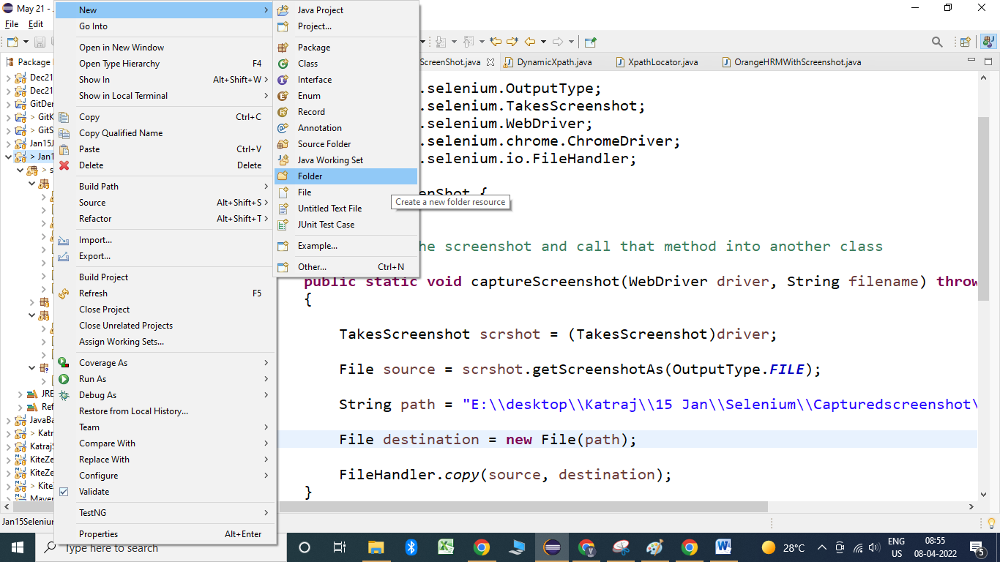

ii. Provide the name of folder and click on finish.

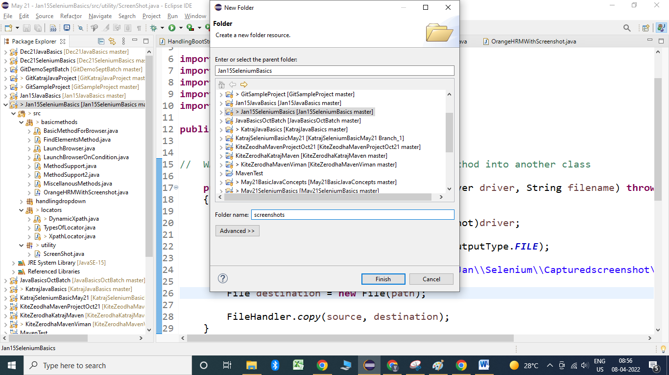

**public** **static** **void** captureScreenshot(WebDriver driver, String filename) **throws** IOException

{

TakesScreenshot scrshot = (TakesScreenshot)driver;

File source = scrshot.getScreenshotAs(OutputType.***FILE***);

// String path = "E:\\desktop\\Katraj\\15 Jan\\Selenium\\Capturedscreenshot\\"+filename+".png";

// Alternate way to define the path

String path = System.*getProperty*("user.dir")+"\\screenshots\\"+filename+".png";

File destination = **new** File(path);

FileHandler.*copy*(source, destination);

}